**BUS TICKET RESERVATION SYSTEM**

**Project report submitted in partial fulfillment of the Requirements for the Award of the Degree of**

**BACHELOR OF TECHNOLOGY**

**In**

**COMPUTER SCIENCE AND ENGINEERING**

**By**

**I.B.Tech TRAINEE TEAM**

**Under the Guidance of**

**A. SIVANRAJ**

**TRAINER,BYTEXL**



**DEPARTMENT OF COMPUTER SCIENCE AND ENGINEERING**

**NBKR INSTITUTE OF SCIENCE AND TECHNOLOGY**

**VIDYANAGAR**

**N.B.K.R. INSTITUTE OF SCIENCE AND TECHNOLOGY**

**(AUTONOMOUS)**

**DEPARTMENT OF COMPUTER SCIENCE AND ENGINEERING**



###### CERTIFICATE

This is to certify that the project report entitled YOUR PROJECT TITLE being submitted by

P.SATYA DURGA SANJAY 24KB1A05FH

V.VARUN 24KB1A05NJ

SK.GAFOOR 24KB1A05HJ

In partial fulfillment for the award of the Degree of Bachelor of Technology in Computer Science and Engineering in N.B.K.R. INSTITUTE OF SCIENCE AND TECHNOLOGY is a record of bonafied work carried out under my guidance and supervision.

| **Mrs.B.SRUTHI**  **M.Tech** | **Dr.A.RAJA SEKHAR REDDY**  **M.Tech, Ph.D**  **Head of the Department** |
| --- | --- |

**DECLARATION**

I hereby declare that the dissertation entitled **BUS RESERVATION SYSTEM** submitted for the B.Tech Degree is my original work and the dissertation has not formed the basis for the award of any degree, associateship, fellowship or any other similar titles.

Place: CP LAB,NBKRIST GAFOOR

Date: 5th MAY,2025 24KB1A05HJ

ACKNOWLEDGEMENT

We sincerely express our gratitude to our trainer Mr.A.Sivanraj for his profound time and knowledge in training and making us able to complete the project with best of our knowledge and ability in fulfiling the requirements and source code for the project.

We also thank our respected councellor Mrs.B.Sruthi for guiding us throughout the progress of the project who encouraged and motivated us to design and present the project in a great way

We,the members of the team shall acknowledge that the project is completely discussed and the source code is implemented within ourselves.

**PROJECT IMPLEMENTATION**

The whole work had been distributed among the members.Each of us has shared the work equally among ourselves in choosing,designing,editing and presenting the project in a clean way.

Our first member, **Satya Durga sanjay** had developed the source code for the project by verifying and referring various websites and applications related to online reservations.

The second member and the most active person in the team, **Varun** had been curious in designing the PPT and referring various books related to C language and data structures to know much about pointers which has been a major and key role in designing the project.

The other member in the team, **Gafoor** was thoroughly guiding and monitoring the work at every interval as well as contributing his work regarding presentation of the project.

**TABLE OF CONTENTS**

**1.INTRODUCTION**

- BUS RESERVATION SYSTEM

- COMPONENTS

- ABOUT THE CODE

**2.SOURCE CODE**

**3.OUTPUT**

**INTRODUCTION**

* **BUS RESERVATION SYSTEM**

Bus Reservation System is a tool that allows users to book tickets for their journey in advance. It offers multiple features to provide a hassle-free experience to a traveler. This project aims at building a source code for a simple Online Bus Reservation System.

A sample bus reservation portal view is displayed below.The website allows to display number of booked seats and availability in addition to the fare of the ticket.

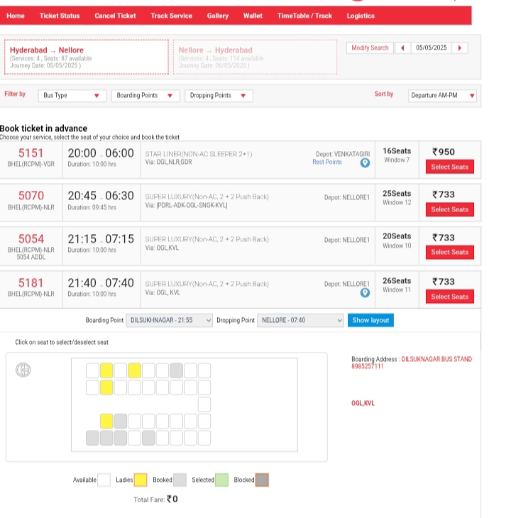

* **COMPONENTS**

Login System: Users can access the system by entering their username . The program provides a collection of preconfigured users and their credentials.

Ticket Purchase: Logged-in individuals may reserve tickets for available buses by entering the bus number and their name. The program allocates a seat number and decreases the number of available seats on the selected bus.

Cancel Tickets: By entering their ticket number, users can cancel their tickets.

Checking Bus Status: Users may check the status of the bus they are currently scheduled to ride on. The program displays availability of seats.

* **ABOUT THE CODE**

The source code is written in C language it comprises of basic functions for various operations regarding ticket bookings,cancellations,etc..The seat numbers and availability are linked to each other by pointers.

Basic structure data type is used to assign node of each function and it is pointed to other node by using pointers.

The display function has been established to show the availability of booked seats in a matrix manner which uses linear traversal in a while() loop.

The contents are executed in the main() function by using the concept of switch() case.The user selects a specific option and the resultant output is displayed on the screen.At every instant,the internal storage is changed and the information is accessed through the arguments.

The "exit" option shall refrains from the loop and hence user can terminate the function at last.

**SOURCE CODE**

#include <stdio.h>

#include <stdlib.h>

#include <string.h>

#define MAX_SEATS 40

typedef struct Ticket

{

char passengerName[50];

int seatNumber;

struct Ticket* next;

} Ticket;

typedef struct BusReservation

{

int seats[MAX_SEATS];

Ticket* head;

} BusReservation;

void initBus(BusReservation* bus)

{

bus->head = NULL;

for (int i = 0; i < MAX_SEATS; i++) {

bus->seats[i] = 0;

}

}

void bookTicket(BusReservation* bus, char name[], int seatNum)

{

if (seatNum < 1 || seatNum > MAX_SEATS || bus->seats[seatNum - 1]) {

printf("Seat %d is not available or invalid.\n", seatNum);

return;

}

bus->seats[seatNum - 1] = 1;

Ticket* newTicket = (Ticket*)malloc(sizeof(Ticket));

if (!newTicket)

{

printf("Memory allocation failed.\n");

return;

}

strcpy(newTicket->passengerName, name);

newTicket->seatNumber = seatNum;

newTicket->next = bus->head;

bus->head = newTicket;

printf("Booking Confirmed: %s -> Seat #%d\n", name, seatNum);

}

void cancelTicket(BusReservation* bus, int seatNum)

{

if (seatNum < 1 || seatNum > MAX_SEATS || bus->seats[seatNum - 1] == 0)

{

printf("Invalid seat or not booked.\n");

return;

}

bus->seats[seatNum - 1] = 0;

Ticket *temp = bus->head, *prev = NULL;

while (temp && temp->seatNumber != seatNum)

{

prev = temp;

temp = temp->next;

}

if (!temp)

{

printf("Booking not found.\n");

return;

}

if (!prev)

bus->head = temp->next;

else

prev->next = temp->next;

free(temp);

printf("Booking for seat #%d cancelled.\n", seatNum);

}

void displayBookings(BusReservation* bus)

{

if (!bus->head)

{

printf("No bookings found.\n");

return;

}

printf("\nList of Bookings:\n");

Ticket* temp = bus->head;

while (temp)

{

printf("- %s has booked seat #%d\n", temp->passengerName, temp->seatNumber);

temp = temp->next;

}

}

void displaySeatMap(BusReservation* bus)

{

int booked = 0;

printf("\nSeat Map (B = Booked, A = Available):\n");

for (int i = 0; i < MAX_SEATS; i++)

{

if (bus->seats[i])

{

printf("[B%2d] ", i + 1);

booked++;

}

else

{

printf("[A%2d] ", i + 1);

}

if ((i + 1) % 4 == 0) printf("\n"); // 4 seats per row

}

printf("\nTotal Seats: %d | Booked: %d | Available: %d\n", MAX_SEATS, booked, MAX_SEATS - booked);

}

int main()

{

BusReservation bus;

initBus(&bus);

int choice, seatNum;

char name[50];

do {

printf("\n==== Bus Ticket Reservation System ====\n");

printf("1. Book Ticket\n");

printf("2. Cancel Ticket\n");

printf("3. Display Bookings\n");

printf("4. Show Seat Map\n");

printf("5. Exit\n");

printf("Choose an option: ");

scanf("%d", &choice);

getchar();

switch (choice)

{

case 1:

printf("Enter Passenger Name: ");

fgets(name, sizeof(name), stdin);

name[strcspn(name, "\n")] = 0;

printf("Enter Seat Number (1-%d): ", MAX_SEATS);

scanf("%d", &seatNum);

bookTicket(&bus, name, seatNum);

break;

case 2:

printf("Enter Seat Number to Cancel: ");

scanf("%d", &seatNum);

cancelTicket(&bus, seatNum);

break;

case 3:

displayBookings(&bus);

break;

case 4:

displaySeatMap(&bus);

break;

case 5:

printf("Exiting... Have a nice day!\n");

break;

default:

printf("Invalid option. Please try again.\n");

}

} while (choice != 5);

Ticket* temp;

while (bus.head)

{

temp = bus.head;

bus.head = bus.head->next;

free(temp);

}

return 0;

}

**OUTPUT**

**A sample output is displayed below the display shows bookings,cancellations and seat availability of a random person.**

